

3 3

2 7

3 4

42 122

int

length,width,height,surfaceare a;

printf scanf



1 70 10

## Code Editor: C/Java/C++

## 

Output:

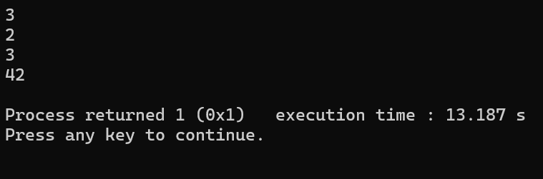

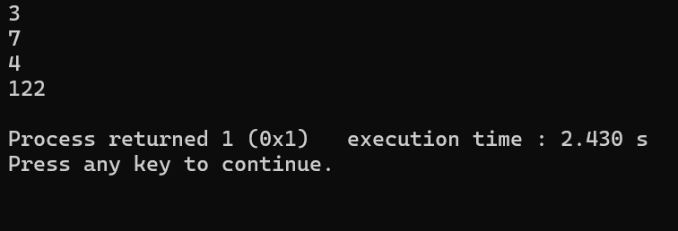

|  |  |  |  |
| --- | --- | --- | --- |
| Criteria | Max Marks | Obtained Marks | |
| Correctness of Algorithms | 20 | |  |
| Time and Space complexity | 5 | |  |
| Use of Appropriate Data Structure | 5 | |  |
| Code Readability and Style | 10 | |  |
| Test case Handling | 10 | |  |
| Total Marks | 50 | |  |

# Signature with Date



1953 8751

3641

7a1

21057

222f



int iplno; scanf printf

1 45 9

## Code Editor: C/Java/C++

## 

## 

Output:

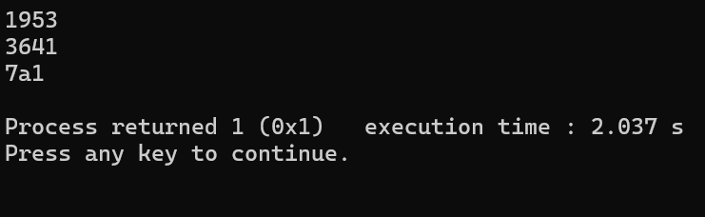

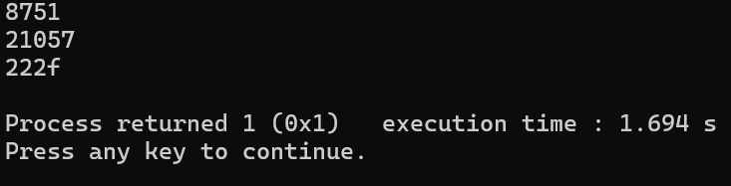

|  |  |  |  |
| --- | --- | --- | --- |
| Criteria | Max Marks | Obtained Marks | |
| Correctness of Algorithms | 20 | |  |
| Time and Space complexity | 5 | |  |
| Use of Appropriate Data Structure | 5 | |  |
| Code Readability and Style | 10 | |  |
| Test case Handling | 10 | |  |
| Total Marks | 50 | |  |

# Signature with Date

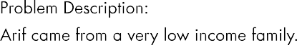

467.78 762.89 945.16 187.49

356864.6875 177208.0469

printf scanf float val1,val2,outcome;

1 61 11

## Code Editor: C/Java/C++

## 

Output:

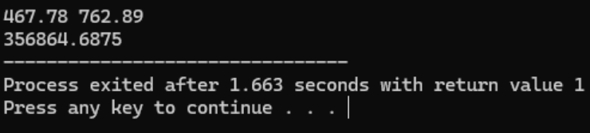

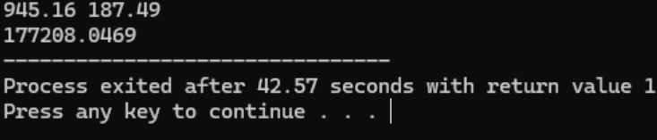

|  |  |  |  |
| --- | --- | --- | --- |
| Criteria | Max Marks | Obtained Marks | |
| Correctness of Algorithms | 20 | |  |
| Time and Space complexity | 5 | |  |
| Use of Appropriate Data Structure | 5 | |  |
| Code Readability and Style | 10 | |  |
| Test case Handling | 10 | |  |
| Total Marks | 50 | |  |

# Signature with Date



7643 3895

3822 1948

int n; scanf printf

1 40 8

## Code Editor: C/Java/C++

## 

## 

Output:

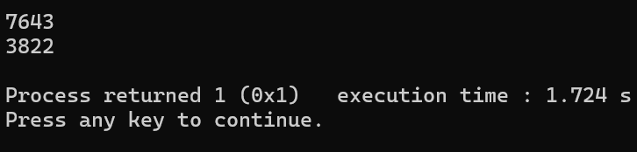

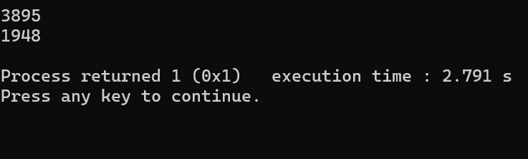

|  |  |  |  |
| --- | --- | --- | --- |
| Criteria | Max Marks | Obtained Marks | |
| Correctness of Algorithms | 20 | |  |
| Time and Space complexity | 5 | |  |
| Use of Appropriate Data Structure | 5 | |  |
| Code Readability and Style | 10 | |  |
| Test case Handling | 10 | |  |
| Total Marks | 50 | |  |

# Signature with Date



23 19

3 5

12167 2476099

unitconsumed costperunit scanf

printf

1 70 15

## Code Editor: C/Java/C++

## 

## 

Output:

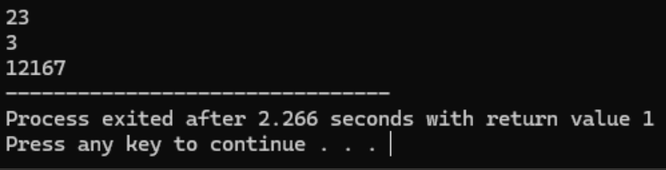

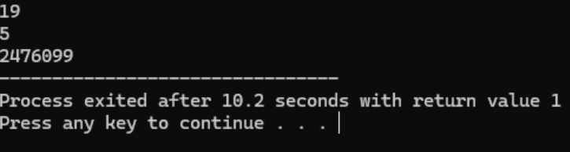

|  |  |  |  |
| --- | --- | --- | --- |
| Criteria | Max Marks | Obtained Marks | |
| Correctness of Algorithms | 20 | |  |
| Time and Space complexity | 5 | |  |
| Use of Appropriate Data Structure | 5 | |  |
| Code Readability and Style | 10 | |  |
| Test case Handling | 10 | |  |
| Total Marks | 50 | |  |

# Signature with Date



3.23

5.67

48.18

17.77

3.230000

5.670000

48.180000

17.770000



float num1,num2; double resnum1,resnum2;

1 80 15

## Code Editor: C/Java/C++

## 

## 

Output:

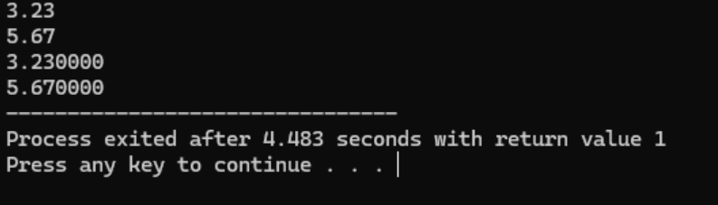

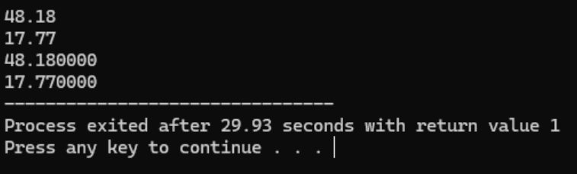

|  |  |  |  |
| --- | --- | --- | --- |
| Criteria | Max Marks | Obtained Marks | |
| Correctness of Algorithms | 20 | |  |
| Time and Space complexity | 5 | |  |
| Use of Appropriate Data Structure | 5 | |  |
| Code Readability and Style | 10 | |  |
| Test case Handling | 10 | |  |
| Total Marks | 50 | |  |

# Signature with Date



600 789

520 256

Quotient:1

Remainder:80

Quotient:3

Remainder:21



int billamt,amtgiven; scanf printf

1 75 15

## Code Editor: C/Java/C++

## 

## 

Output:

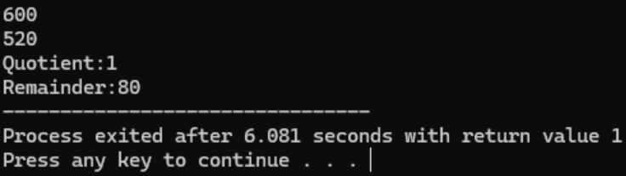

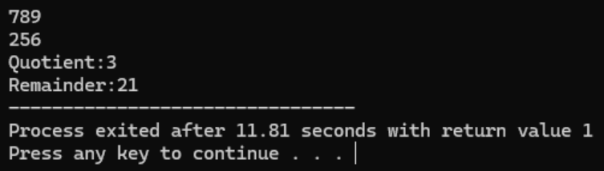

|  |  |  |  |
| --- | --- | --- | --- |
| Criteria | Max Marks | Obtained Marks | |
| Correctness of Algorithms | 20 | |  |
| Time and Space complexity | 5 | |  |
| Use of Appropriate Data Structure | 5 | |  |
| Code Readability and Style | 10 | |  |
| Test case Handling | 10 | |  |
| Total Marks | 50 | |  |

# Signature with Date



17 21 32 49

12.32883 27.01851 37.10795 58.52350

float b,ls,rs1,rs2; scanf printf

1 80 11

## Code Editor: C/Java/C++

## 

Output:

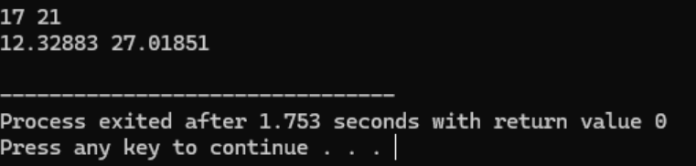

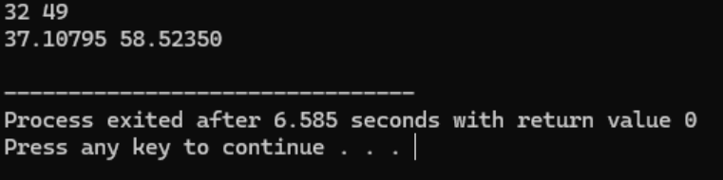

|  |  |  |  |
| --- | --- | --- | --- |
| Criteria | Max Marks | Obtained Marks | |
| Correctness of Algorithms | 20 | |  |
| Time and Space complexity | 5 | |  |
| Use of Appropriate Data Structure | 5 | |  |
| Code Readability and Style | 10 | |  |
| Test case Handling | 10 | |  |
| Total Marks | 50 | |  |

# Signature with Date



19845.67 12985.59 23985.12 6545.51

32831.258 30530.629

printf scanf float var1,var2,res;

1 65 11

## Code Editor: C/Java/C++

## 

Output:

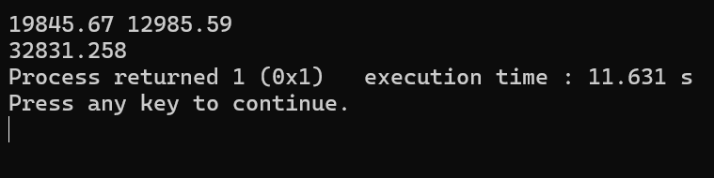

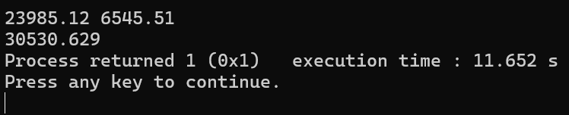

|  |  |  |  |
| --- | --- | --- | --- |
| Criteria | Max Marks | Obtained Marks | |
| Correctness of Algorithms | 20 | |  |
| Time and Space complexity | 5 | |  |
| Use of Appropriate Data Structure | 5 | |  |
| Code Readability and Style | 10 | |  |
| Test case Handling | 10 | |  |
| Total Marks | 50 | |  |

# Signature with Date



5 10 15 3 5 6

30 14

int num1,num2,num3; int sum; printf

scanf

1 70 15

## Code Editor: C/Java/C++

## 

Output:

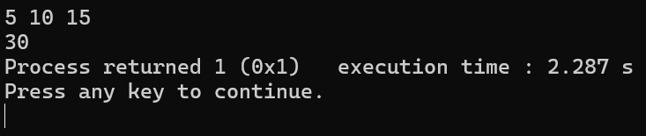

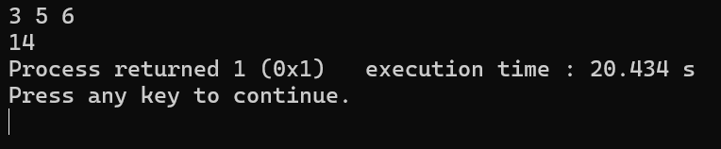

|  |  |  |  |
| --- | --- | --- | --- |
| Criteria | Max Marks | Obtained Marks | |
| Correctness of Algorithms | 20 | |  |
| Time and Space complexity | 5 | |  |
| Use of Appropriate Data Structure | 5 | |  |
| Code Readability and Style | 10 | |  |
| Test case Handling | 10 | |  |
| Total Marks | 50 | |  |

**Signature with Date**